Swagger

Response json swagger memanggil data WeatherForeCast

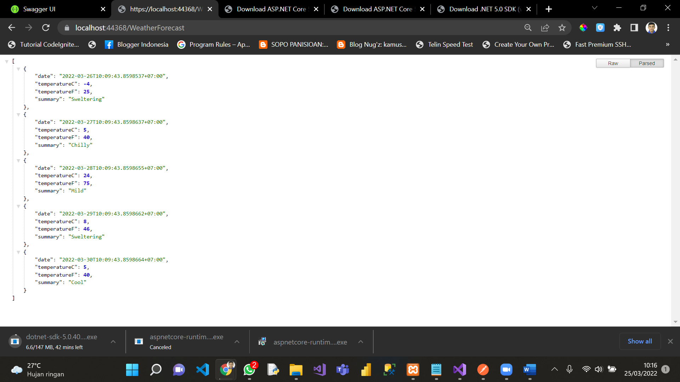

Postman

Postman Response json memanggil data WeatherForeCast

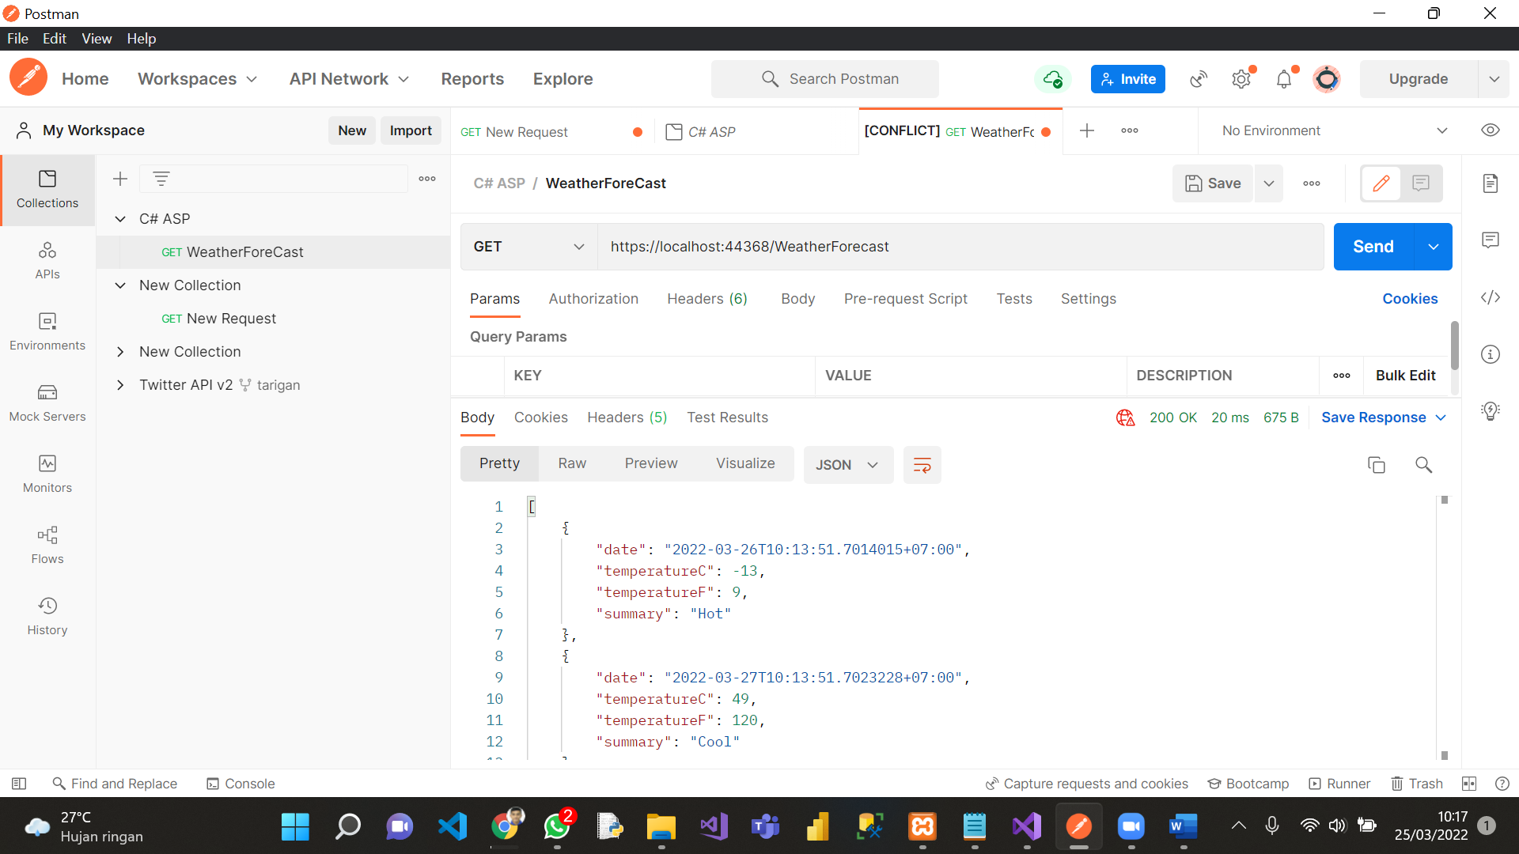

Kantor WebAPI

1. Response swagger memanggil semua data di table employee

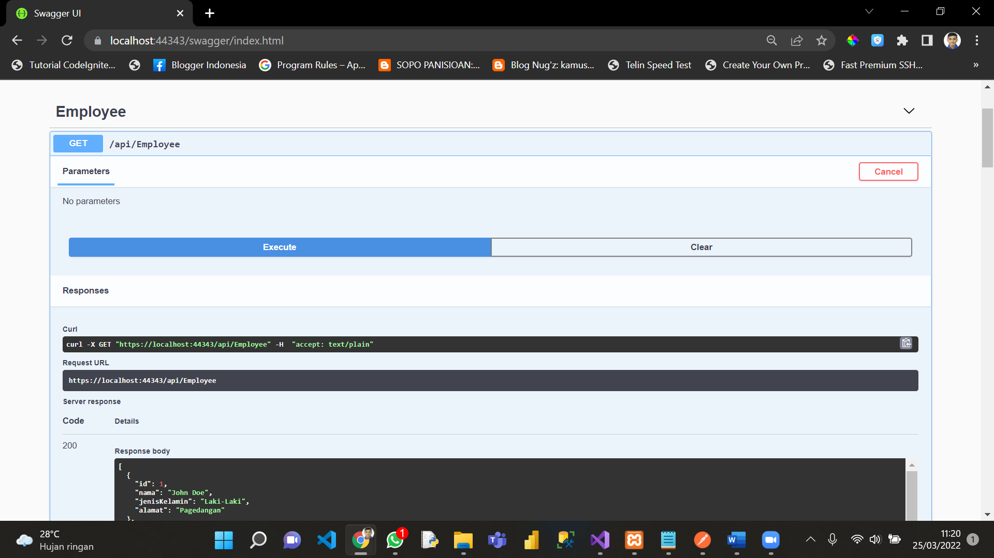

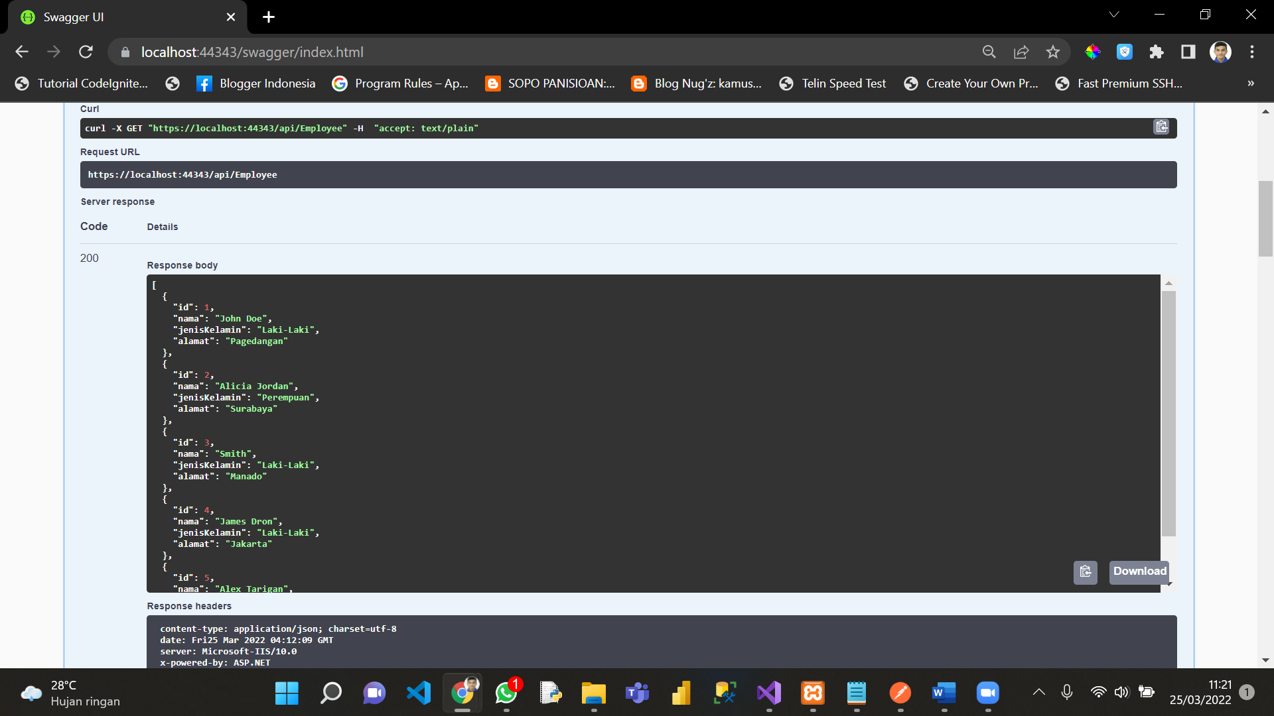

2. Response swagger memanggil semua data di table employee WHERE id = 5

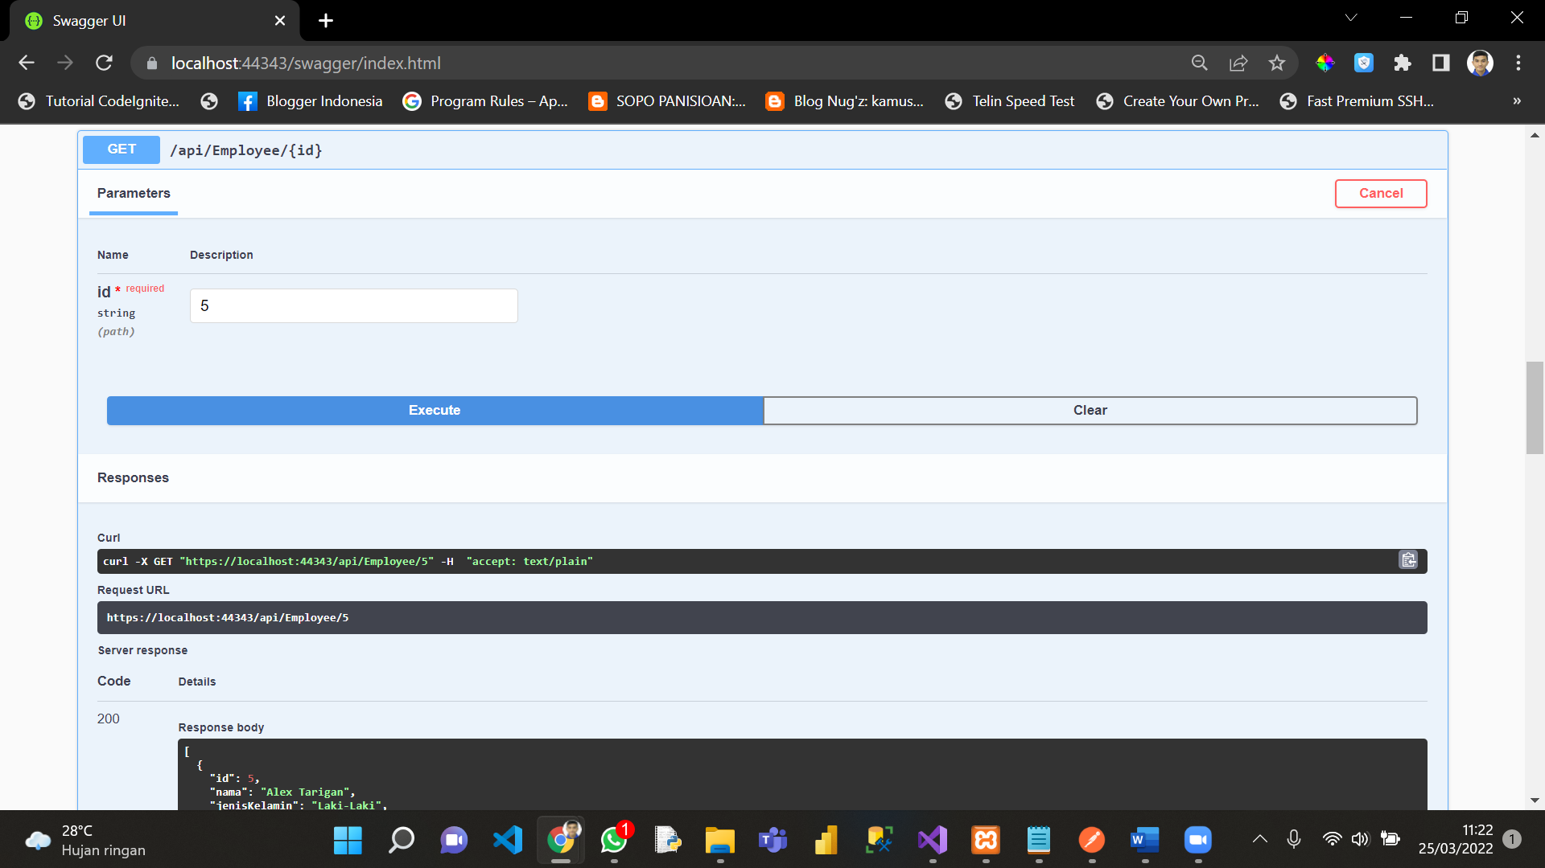

3. Response swagger memanggil data **WeatherForecast**

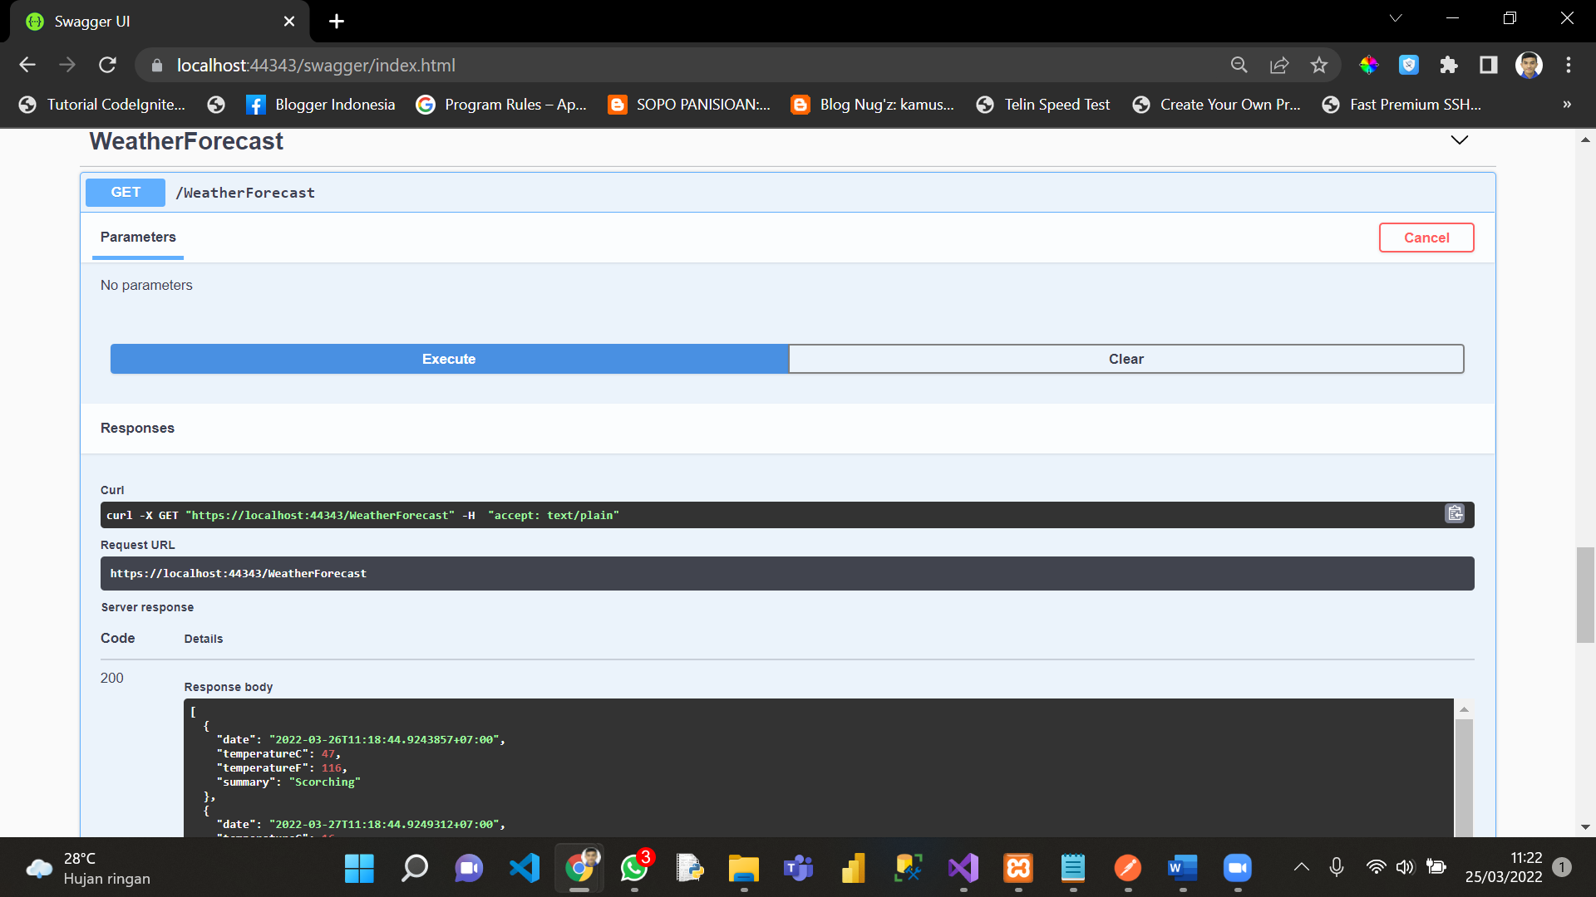

4. Response swagger memanggil schema

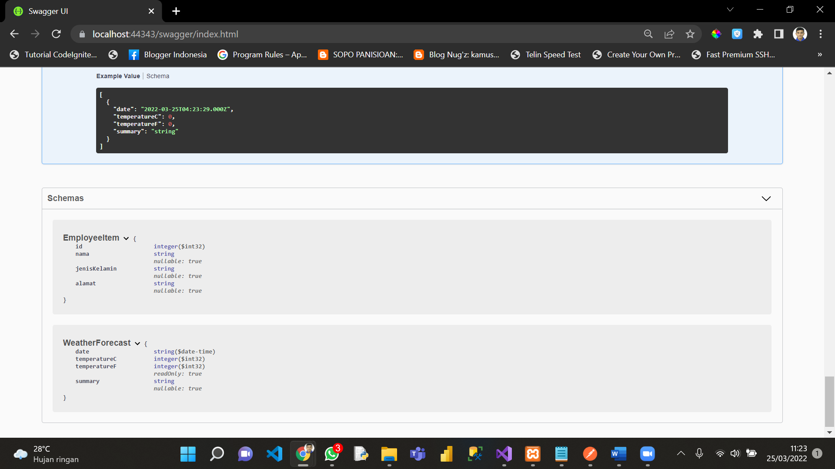

5. Response POSTMAN memanggil semua data di table employee

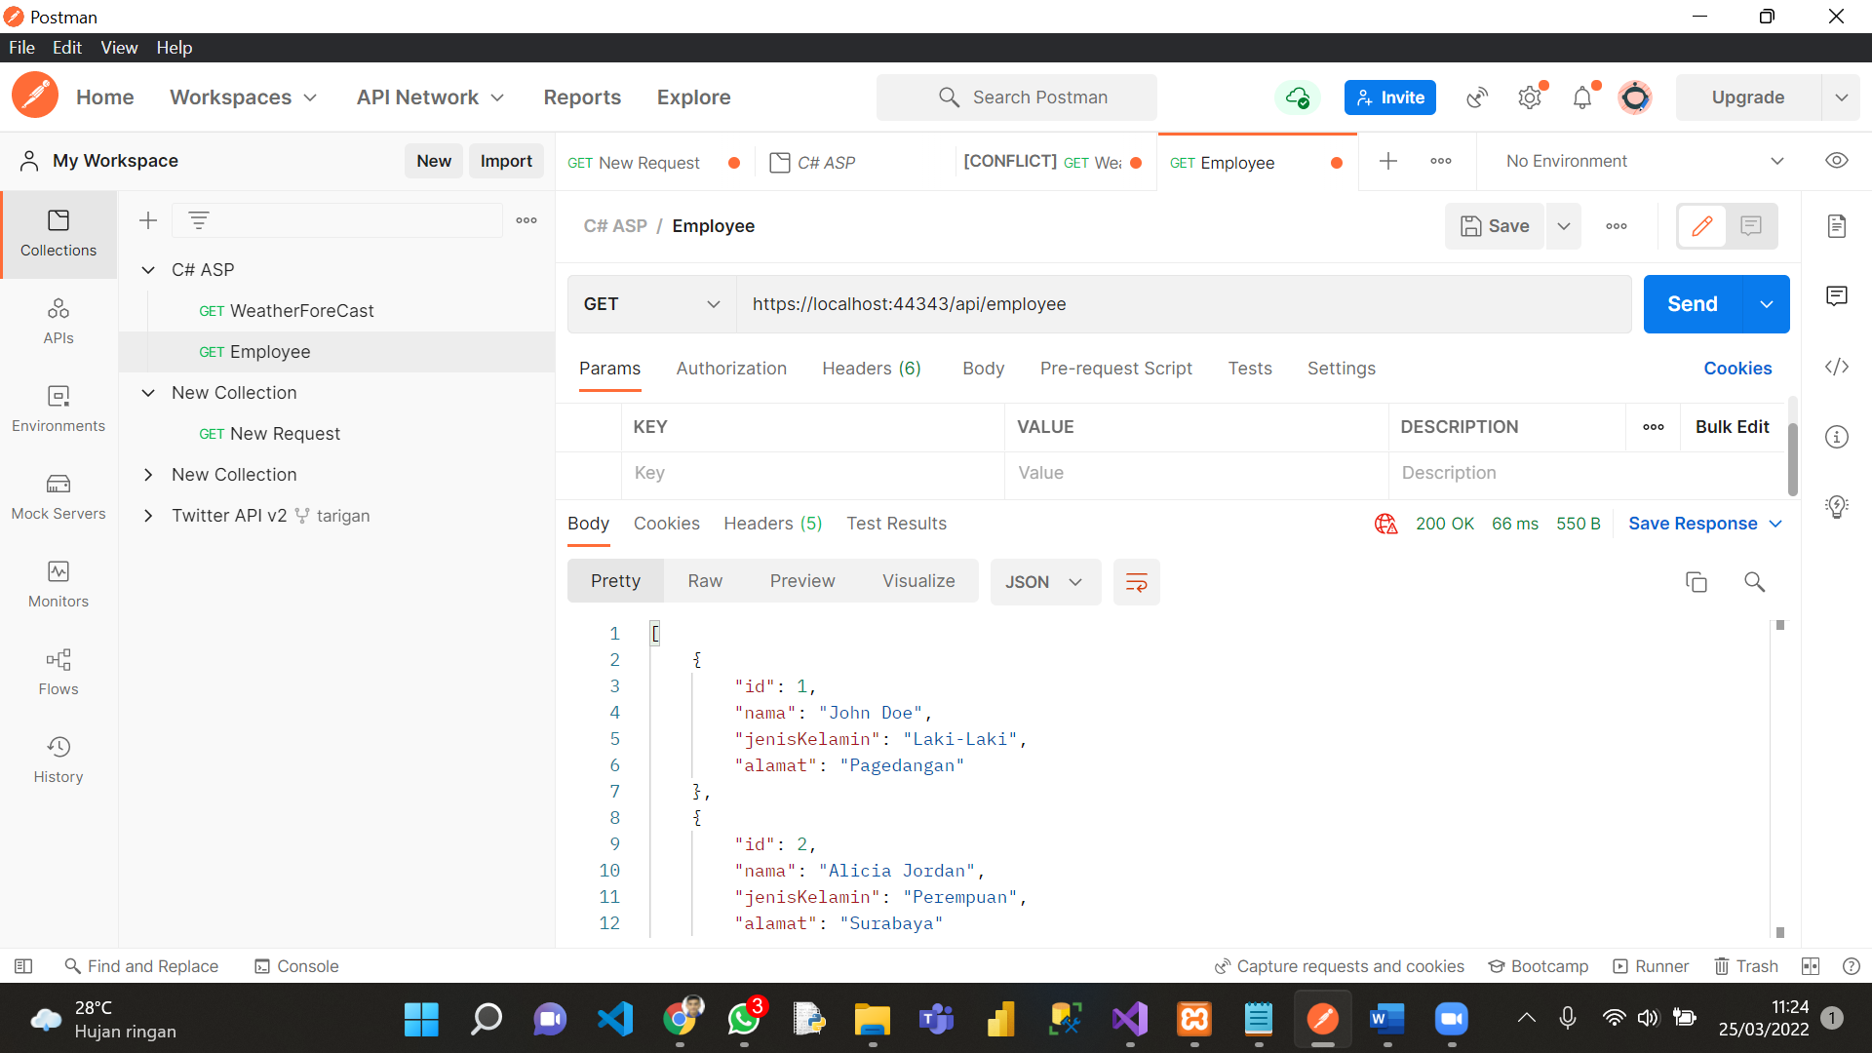

6. Response postman memanggil semua data di table employee WHERE id = 5

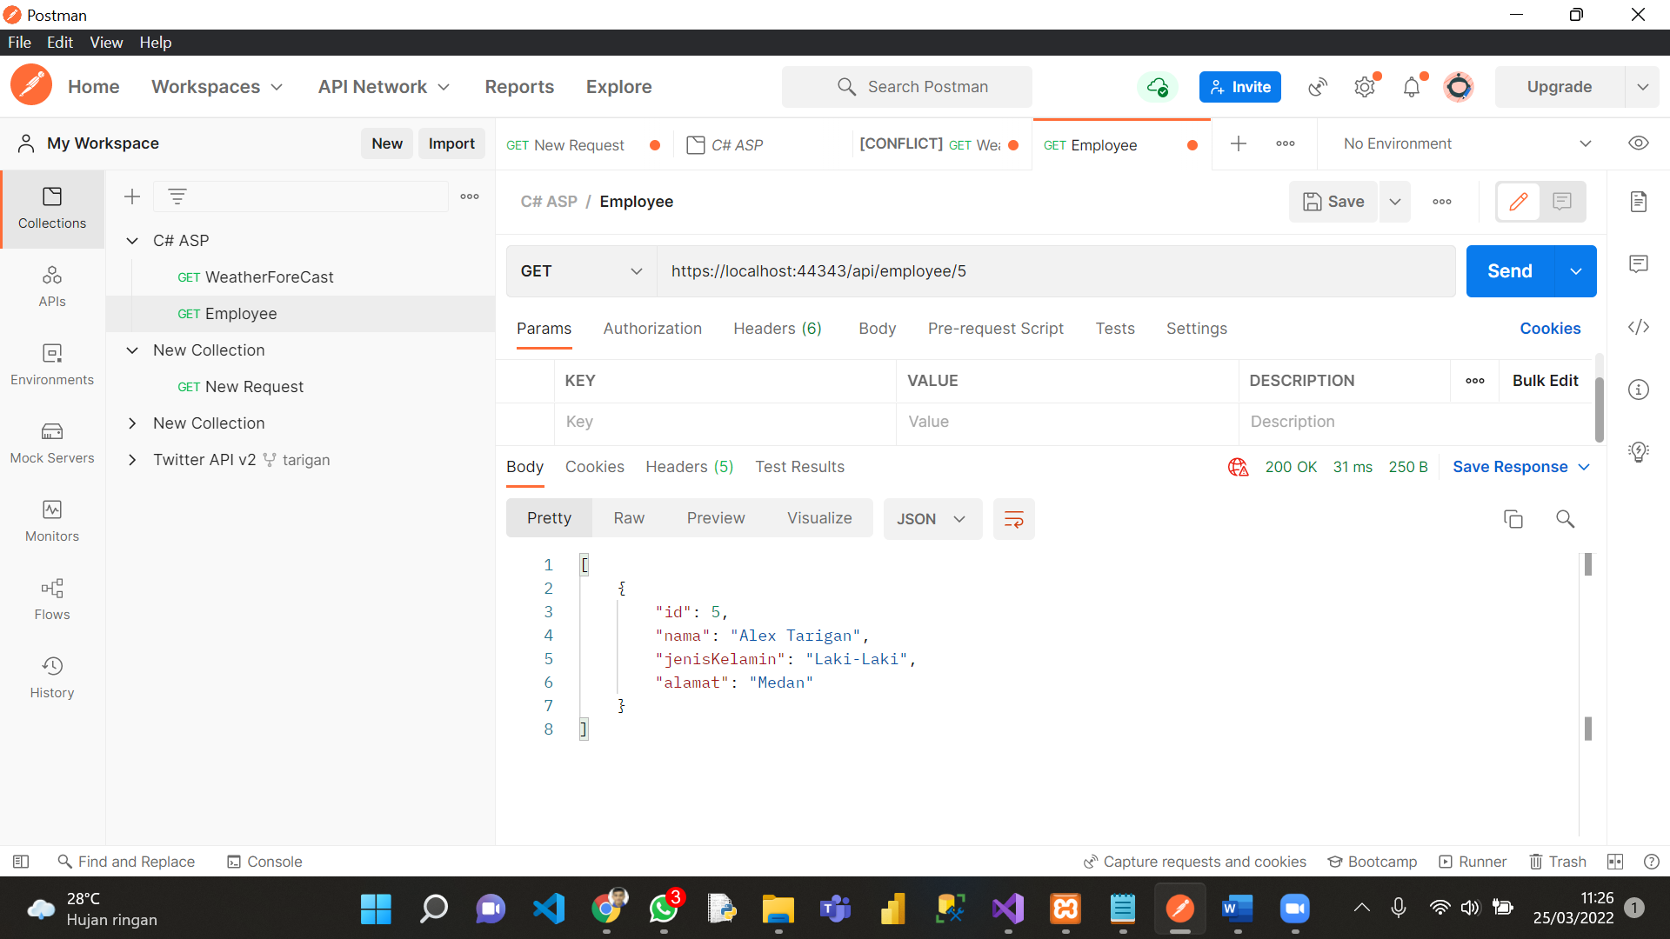

Response postman memanggil semua data di table employee WHERE id = 3

